**Day-1 (Assignment-2)**

# **q)Draw your Home Network Topology and explain how you are accessing the RPS Lab environment.**

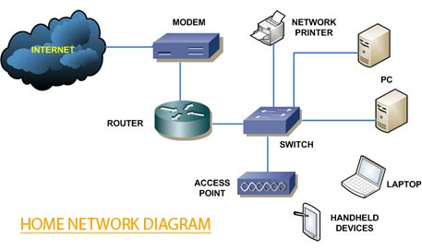

## **1) Internet**

The internet, sometimes simply called the net, is a worldwide system of interconnected computer networks and electronic devices that communicate with each other using an established set of protocols.

## **2) Modem**

A modem is a device that allows computers, smartphones, tablets, and other devices to connect to the internet. It does this by converting digital signals from these devices into analog signals that can be transmitted over telephone lines or cable networks.

## **3) Router**

A router is a device that connects two or more packet-switched networks or subnetworks. It serves two primary functions: managing traffic between these networks by forwarding data packets to their intended IP addresses, and allowing multiple devices to use the same Internet connection.

## **4) Devices**

A device is a unit of physical hardware or equipment that provides one or more computing functions within a computer system. It can provide input to the computer, accept output or both.

* **Smartphone**: Connects wirelessly to the router.
* **Laptop**: Connects wirelessly to the router.
* **Desktop Computer**: Usually connects to the router via an Ethernet cable for a stable connection.
* **Smart TV**: Can connect wirelessly or via an Ethernet cable.
* **Printer**: Can connect wirelessly or via an Ethernet cable.
* **RPS Lab Computer**: A computer dedicated to accessing the RPS Lab environment, usually connected via Ethernet for a stable and fast connection.

## **A Accessing the RPS Lab Environment**

1. **Connect to the Internet**

Connect to Wi-Fi by going to your network settings, turning in Wi-Fi, and selecting your network name. Connect to dial-up by plugging in your modem to the phone jack, then connecting the modem to your computer.

1. **VPN (Virtual Private Network)**

Many labs require a secure connection. You might need to use a VPN to securely connect to the RPS Lab network. The VPN will create a secure tunnel from your device to the lab's network.

1. **Remote Desktop Software**

Use software like Remote Desktop Protocol (RDP), VNC, or other remote access tools to connect to the specific computer or server in the RPS Lab. This software allows you to control the lab computer as if you were sitting right in front of it.

1. **Login Credentials**

Enter your lab credentials (username and password) to access the resources within the RPS Lab environment.